Krystian Szymanski

IT SUPPORT ENGINEER

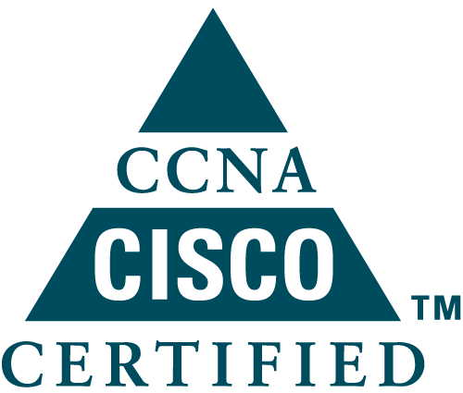
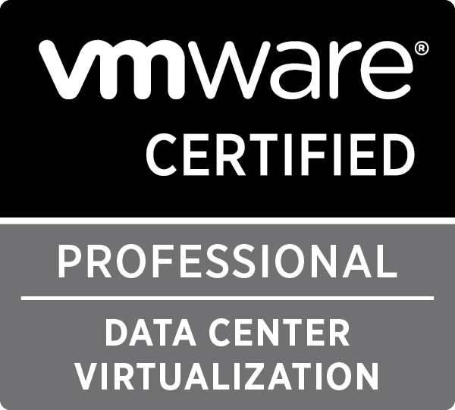
307 Lodge Causeway
BS16 3PG Bristol

07849474947
Krystian.szymanski@yahoo.com
http://krystianszymanski.weebly.com

Personal summary
Ready for new challenge - solid, highly motivated and proactive IT Support Engineer/Data Centre Engineer with hands on experience in London and Bristol coupled with VCP (recently) CCNA and MCSA qualifications.
Presents strong installation, maintenance and problems solving skills accompanied by excellent customer service skills. Recognised for ability to adapt technical understanding in multiple environments, having an eye for detail and able to multi-task under pressure.
An excellent communicator, can relate well with people at all levels and has the flexibility of working well as part of a team and on my own.

Personal skills

Excellent customer service skills - ability to teach highly technical content to users, with any technical level of experience, respond to every query with care, respect and understanding. Well organized, dependable, quick-thinking with a lively interest in Information Technologies.

Capacity to solve problems - ability to solve logic problems, uncovering hidden clues,
and discovering and attempting solutions without exacerbating the problem further

Ability to multitask and stay calm under pressure - linear and logical troubleshooting

Talent for communicating - ability to communicate technical information to non-
technical users and to acquire technical information from those that cannot explain the
problem clearly,

Technical aptitude - enjoy working with technologies, computers, advanced hardware and
software

Ability to work on own initiative or work as part of a team

Technical skills and product knowledge

HARDWARE
- Knowledge of wide range servers – all brands (mainly HP Proliant and DELL PowerEdge)
- Build, configuring, increasing performance - custom PCs,
- Installing and configuring network equipment Cisco, TP Link, Netgear
- Installing, racking, connecting storages and brocades – EMC, 3PAR, Nexsan
- Printers and scanners - Installing, configuring and maintaining
- Installing, building, configuring, upgrading, troubleshooting any type of laptops/netbooks/tablets
- Configuring, upgrading mobile devices based on Windows Mobile, Android, iOS, Blackberry

SOFTWARE
- MS Windows Desktop Systems – DOS/95/Me-98/2000/XP/Vista/7/8/10
Installing, configuring, patching, troubleshooting
- MS Windows Server Systems – 2003/2008/2012 Installing, configuring, patching, troubleshooting
- Linux – CentosOS – installing, preconfiguring, joining to windows domain, edit proxy, squid lists
- Virtualization Software – VmWare ESXi, Workstation, Installing, configuring, troubleshooting
Installing VMs, migrating, clustering, hosts, data stores, networking, etc
- Active Directory, GPO,DHCP,DNS,NTFS/DFS,WDS,MDT,WSUS,SNMP
- Exchange 2010 / outlook/ I Critical Security – new accounts distribution groups, monitoring
- Remote Desktop – RDP, VNC, Team Viewer, Log Me In
- Backup solutions / Recovery data – Acronis, Symantec, KarenWare, Microsoft
making backups, imaging hard drives, systems, recovering systems and data
- Antivirus/Firewall software – Microsoft, Kaspersky, Eset, Symantec, Avg,McAfee, Comodo
Implementing, configuring, troubleshooting, removing, securing small offices, business and home networks against malicious attacks, viruses, spam, other types of malware
- MS Windows Applications – Office 97/XP/2003/2007/2010/2013
Installing, troubleshooting, supporting users
- SQL Windows server (basic server installation, database creation, users – privileges)

NETWORKING
- CISCO switches + routers, firmware, config,
- TCP/IP networks wired and WiFi networks
- VLANS, Trunks – working knowledge

STORAGE
- DELL Equallogic- upgrade firmware on shelves, joining to the group, Create LUNs, presenting as datastore in Vsphere

Work experience

3rd Line IT Support

09/2015 – Present at DST Output, Bristol

- 2nd/3rd Line Telephone & Remote Access Support to clients
- Dealing with Support Queries via Ticketing System/Email/Telephone
- Server Win2008/12,CentosOS (installation, administration ,troubleshooting, patching)
- Active Directory management + GPO, DNS,DHCP,NTFS/DFS, Print Server,MDT,WSUS
- VMWARE – administering 1 site, 6 clusters, 24 hosts, 400 vms, acces to another 6 sites and 500 vms
- Networking – mainly switching, VLANS, Trunks, Etch Chanel, WiFi, firmware, config, VTP
- Managing SFTP servers / accounts – new accounts, troubleshooting connectivity
- Managing BACKUPS – ARC Server UDP – adding hosts, creating plans, backup server installation
- Monitoring Servers and networking - Cacti, Check MK, space observer
- VPN – administering accounts, access, troubleshooting
- Security – Managing McAfee server, Bitlocker, Truecrypt
- Managing IP telephony – Mitel IP, Webex, Conferences
- Supporting users from low level to CEO, locally and remotely
- Helping and troubleshooting production / office software
- Mentor and support junior engineer

Recent Projects:

- Install new backup server with Dell storage + install and configure software + hardware
- Migrate ESXi hosts from one DC to another
- Migrate Dell Storage from one DC to another
- Migrate Users from old Access switches to new access stack
- Migrate users and computers from one domain to another one
- Prepare backup plans for production servers

Data Centre Senior IT Engineer
12/2013-09/2015 at Datapipe, London

Additionally to previous position:
- One of Team Leader responsible for line managing teams of up to 4 staff
- Training new employees
- Assisting / supporting Windows team with Windows Server 2003-2008 and 2012 / installation, deployments, troubleshooting and automation. Troubleshoot software issues and escalate accordingly
- Duties include preventive maintenance to prevent failures on hardware and software
- Remote support for hardware and software issues

Data Centre IT Engineer
12/2011-12/2013 at Datapipe, London
- Installing, configuring, troubleshooting HP and Dell servers
- Configuring RAID 0,1,10,01,5,brake,iLO,Drac
- Firmware and Bios upgrade on servers
- Respond, action and resolve request /faults logged both internally and externally
- Installing switches, routers and network hardware
- Fixing broken servers
- Active monitoring of 1000s of servers in various locations in the world
- Monitoring all DC resources
- Work with operation engineers in configuring customers requirement
- Installing and pre-configuring MS Windows Server systems
- Installing and pre-configuring Citrix XEN server and VMware ESXi
- Installing shelves, power strips, rails, cable management
- Cabling using copper and fiber cables + testing
- Racking, stacking equipment + hardware decommissioning

IT Support Engineer / 2rd -3rd

line
4/2008 – 12/2011 at LGC Computers, Warminster n/Bath, Wilts.

- Managed and Administered Windows XP and Windows 7 / Vista workstations and laptops.
- Virtualizing operating systems using VMware software like VM Workstation,
- Configuration and testing of any new hardware and software
- Building and installing high performance custom PC’
- Diagnosing, testing, analyzing and resolving user laptop, PC software and hardware issues
- Installing and configuring new and refurbished computers / laptops
- Training and coaching users effective use of computer software and hardware in windows and other computer OS
- Providing support for desktop applications ( MS Office, Operating systems, etc )
- Supporting users remotely and on site with installs, deployment, and troubleshooting
- TCP/IP networking and hardware maintenance and repair
- Printers – installing, configuring, troubleshooting
- Ensuring the anti-virus software is installed, properly configured, regularly updated and working properly / removing virus
- Implementing data security such as securing small office and home networks against malicious attacks, viruses
- Recovering data / providing backup solutions
- Advising on IT equipment to assess and satisfy future needs of the customers

IT Support Engineer / 1st to 3rd line / Owner
8/2002 - 1/2005 at NAUTILUS - New Computer Technologies, Poland - Microsoft’s Business partner
- Personal responsibility for 1-3 st technical support for private, public sector enterprises
- Building Customized PCs and Servers
- Diagnosing and resolving problems with IT infrastructure,
- Consultancy on computer hardware and software development for future needs of our business clients,
- Software audits and licensing services,
- Installing and supporting Microsoft desktop and server operating systems,
- Maintaining wired and wireless networks
- Configuring IT hardware and software at customer sites,

IT Support Engineer / 1st line
01/2000 - 4/2002 at OIKOS – Real Estate Agency
- Personal responsibility for 1st line technical support
- Supporting desktop users
- Configuring, maintenance troubleshooting hardware and software issues
- Administrator and creator of www service
- Graphic designer

Professional training

- 2017 VCP VMWARE Certified Professional - Certificate
- 2017 MS SharePoint - training
- 2016 CCNA Security – Firewalls, VPN - training
- 2016 CCNA Cisco Certified Network Associate (Cisco Networking Academy) – Certificate
- 2012 MCP Exchange 2007 - Certificate
- 2011 MCP Implementing, Managing & Maintaining MS Windows Server 2003 Network
Infrastructure - Certificate
- 2011 MCP Managing and Maintaining a Microsoft Windows Server 2003 - Certificate
- 2010 MCP Implementing and Supporting MS Windows XP Professional - Certificate
- 2009 CCNA Cisco Certified Network Associate (Cisco Networking Academy) – Certificate
- 2004 Microsoft Certificate of Software Assets Management
- 2004 Microsoft Licensing Specialist
- 2004 Microsoft Small Business Server 2003 Premium – advanced config. of the server
components
- 2004 Microsoft Windows 2003 Server – techniques
- 2003 Microsoft Office System 2003 - concerning the sale of solutions
- 2003 Microsoft OEM Reinstallation Kit - issues of pre-instalation MS Windows 2003 Server
with OPK tool for OEM System Builders
- 2004 Certificate of Authorized Server Training - organized by Microsoft, Intel, Adaptec,

Personal information
- Nationality Polish, UK Resident since 2005
- Driving licence Full Driving Licence (own transport)
- Hobbies Information Technologies, automotive

References available upon request

